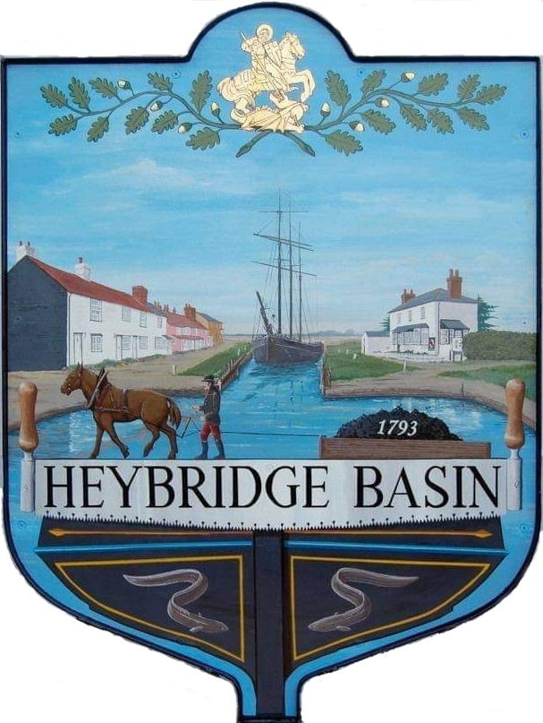

HEYBRIDGE BASIN PARISH COUNCIL

Minutes of the Full Council meeting of Heybridge Basin Parish Council held on Tuesday 19th September 2023 at 6.30pm

Present – Cllrs M. Hodges (Chair), R. Bryson (Vice Chair), M. Hobden, G. Howat, C. Swann, and J. Sjollema.

Also present – G. Lake – Clerk, and 3 members of public.

Recording of meetings
Please note, the Council may have recorded any part of this meeting held in open session. Members of the public who attended the meeting and spoke are deemed to have given permission to be included in the recording.

23/60 Chair’s Welcome
The Chair opened the meeting and informed members that he had attended the Royal Merchant Navy Day as well as the Regatta Committee’s AGM.

23/61 Apologies for Absence.
- To receive and accept apologies for absence.
Apologies for Cllr Edmond were approved.

23/62 To receive Declarations of Interest in accordance with the Council’s Code of Conduct and with section 106 of the Local Government Finance Act 1992.
Cllr Hobden – Non-Pecuniary – HBSA, Basin Oars and HB Rivercare; Cllr Howat – Non-Pecuniary - HBCSA, Cllr Swann – Non-Pecuniary owner of Tea room and DMCP, Cllr Bryson – Non-Pecuniary – DMCP

23/63 To sign as a correct record the minutes of the full council meeting held on 18th July 2023.
The Minutes as previously circulated were agreed as a correct record.

Cllr Sjollema arrived at 6:32pm

23/64 To receive a report from the District and County Councillors for the area on any matters of interest.
Reports from the District Cllrs had been circulated. No report from Cllr Durham

23/65 Finance.
- To approve
- Payment requests for July/August/September 2023.
The Payments as previously circulated were approved.
- Receipts for July/August/September 2023.
The receipts as previously circulated were approved.

23/66 Internal Audit
  - To consider the quote from April Skies for the 2023/2024 Internal Audit and agree any action to be taken.
It was resolved to accept the quote and appoint April Skies as the Internal Auditor for 2023/2024.

23/67 United Reformed Church
- To receive an update from the Clerk and agree any action to be taken.
The Clerk read out a letter from the owners of the URC and informed members that Maldon District Council (MDC) were seeking evidence of the previous uses of the building, with a deadline date of 29th September 2023.
It was resolved for all to acquire and send evidence to the Clerk. It was resolved to write to the owners of the URC to organise a meeting should the application be with MDC be successful.

23/68 On-Street Parking
- To receive an update from the Working Group and agree any action to be taken.
Support from County Cllr Durham was received. It was resolved to circulate the petition to all impacted properties, gather the feedback and submit to the South East Parking Partnership (SEPP)

23/69 Village Design Statement
- To consider creating a Working Group to review the Village Design Statement and agree any action to be taken.
It was resolved to set up a Working Group led by Cllr Howat with Cllr Sjollema, the Chair of the HBCS and 2 residents who have volunteered.

23/70 Remembrance Sunday
- To consider plans for Remembrance Sunday and agree any action to be taken.
It was resolved to organise a small service for Saturday 11th November at 11am.
- To consider the letter from Royal British Legion and agree any action to be taken.
It was resolved to write the names of the Basiners who had died in service on the cross and donate £50.00 to the Royal British Legion (RBL)

23/71 Public Forum
1 member of public spoke about the Boat Yard planning application.

The planning agent for the Boat Yard application arrived at 19:25pm

The Chair permitted a 5-minute Q&A session with the planning agent.

23/72 DMCP
- To receive an update from the WG and agree any action to be taken.
A report was read out by the WG.
It was resolved that Cllrs Hodges and Bryson would open the sealed tender bids on Wednesday 1st November with the Clerk.
It was resolved that Cllr Hodges would create a spreadsheet to compare contractor details and pricing.
It was resolved that the WG would select a minimum of 3 contractors to ‘normalise’ and gather feedback for Council to select a contractor at the November meeting.
It was resolved to order the FIDO 25 dog waste bin from Glasdons.

It was noted that the Leylandii works are scheduled in for week commencing 16th October and would take around 3-4 days.
It was reported that the fencing around the Leylandii would become damaged. It was resolved for the WG to seek quotes to repair/replace some of the panels including 2 gates which can be padlocked.

It was recommended that the drain in the middle of the car park needs cleaning. The WG had approached HRS Marine Services for a quote.
It was resolved to accept the quote of £480.00 from HRS Marine Services and for works to be completed at the same time as the Leylandii.
Cllr Swann did not participate in the conversation and abstained from voting due to a conflict of interest.

23/73 Planning Applications
- To consider any planning applications received after the publication of the agenda and to agree the action to be taken.

23/00865/FUL – Boat Building Yard – Lock Hill - Demolition of existing buildings, and construction of 4 no. mixed use live/work units, provision of hard and soft landscaping, sustainable drainage, vehicular access, and associated works. It was resolved to recommend the refusal of planning permission with the same comments the Council made for the previous application.

The planning agent left at 19:54pm

23/74 Clerk’s Report
- Land adjacent to St Georges Church – The Clerk had called HM Land Registry and was unable to get an update until it had been received by the caseworker.
- Bus Shelter Land -
- MDC - Goals and pedestrian sign – Clerk had been advised for the Council to purchase their own pedestrian sign. It was resolved for the Clerk to seek quotes for the pedestrian sign. MDC had informed the Clerk that they would not insure nor inspect the goalposts as they would be purchased by the Council. It was resolved for the Clerk to liaise with MDC regarding inspection costs.

23/75 Correspondence
- To note correspondence received and any actions to be taken.
Correspondence was noted and responses were agreed.
It was resolved to donate £50.00 to Friends of Heybridge Cemetery.
It was resolved to donate £100.00 to Essex and Herts Air Ambulance.
It was resolved for the Clerk to seek quotes to have the hedges along Basin Road cut.
It was resolved for the Clerk to accept Essex County Council’s (ECC) offer to write to landowners of the Lock sluice.

It was resolved to extend the meeting until 9pm

23/76 Newsletter
- To consider items to be included in the next Parish Council Newsletter and agree any action to be taken.
- Upcoming works in DMCP
- Village Design Statement
- Remembrance Sunday
- United Reformed Church
- Defibrillator Training
- Boat Yard Planning application
- Basin Book Exchange

23/77 Local Issues
- To note any items of inclusion on the agenda for the next meeting of the Parish Council.
- Budget

23/78 Pursuant to section 1(2) of the Public Bodies (Admission to Meetings) Act 1960 it is resolved that, in view of the confidential nature of the business about to be transacted, it is advisable in the public interest that the press and the public be excluded, and they are instructed to withdraw.

Members of the public left as well as Cllr Sjollema

23/79 DMCP
- To receive an update from the WG and agree any action to be taken.
A report was received from the WG.
It was resolved for the Clerk to respond to the MP regarding the shingled area of the car park and to organise a meeting with the residents who may be impacted by any changes to this area.
It was resolved for the Clerk to apply for planning permission to remove the conifers and Laurels on the left-hand side of the access road, as well as seeking quotes for the works to be undertaken including fencing and/or landscaping options.
It was resolved for the Clerk to organise a meeting with the residents of Rohan house.
It was resolved for the Clerk to seek quotes for a dilapidation survey to Rohan house.

23/80 Personnel Matters
- To agree the amendment to the Clerks contract regarding holiday entitlement.
The amendment to the Clerks contract was agreed.
- To note the Clerk’s accrued holiday entitlement from 2022/2023.
It was noted that the Clerk had accrued 63.7 holiday hours which would be paid in October.

There being no further business the meeting closed at 09:00pm
Provisional Date of the next Council Meeting Tuesday 17th October 2023.

Clerk Contact details: clerk@heybridgebasinpc.org.uk
Website: www.heybridgebasin-pc.gov.uk

